44.25: 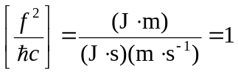
and thus 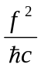 is dimensionless. (Recall 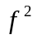has units of energy times distance.)

